New York City Children’s Chorus
at Madison Avenue Presbyterian Church

Handbook

Contact Information
212-288-8920
www.nycchildrenschorus.org

Mary Huff, Artistic Director (mwh@mapc.com)

Updated: March 2016
Mission Statement

The New York City Children’s Chorus is a graded choral program for children in the metropolitan New York City area who wish to receive training in the art of singing in a rigorous and rewarding choral environment. The program will enable choristers, through hard work and dedication, to develop a passionate commitment to excellence through the choral art, to learn discipline and self-confidence, and to give back to their community through the gift of music.

Policies and Procedures

1. Attendance

Choristers are expected to attend all rehearsals and performances. Rehearsal and concert schedules are circulated to parents during the summer months and confirmed in the Fall. Families are responsible for making sure these schedules are noted well in advance. Should your child become ill on the day of a rehearsal or performance, please email Mary Huff to let her know of your child’s illness and absence.
Excused absences must be cleared in advance and include religious observances and extraordinary family obligations (such as weddings, Grandpa’s 100th Birthday, or a death in the family). Unexcused absences such as birthday parties, weekend getaways/out-of-town homes, play dates and sleepovers, are not acceptable reasons for missing rehearsals and concerts. Emails stating that a child will be absent with no reason given will be considered an unexcused absence. Unexcused absences are cause for dismissal from the program.

2. Auditions and Re-auditions

Auditions for new and returning choristers are held in May and June. All choristers who are currently enrolled and who wish to continue in the program must also re-audition for placement each year. Maximum enrollment numbers have been established for each choir based on the age level and musical requirements for each ensemble. Once capacity in an ensemble is reached, the Artistic Director may wish to maintain a waiting list of prospective choristers in the event of a vacancy.

3. Behavior

Choristers are expected to be respectful toward each other, the NYCCC and MAPC staff, parent chaperones, concert hosts, and audience members at all times. Similarly, they are expected to treat their sheet music, the MAPC building, and other facilities where they are guests, with care and respect. Choristers that are not respectful towards people and property will be disciplined appropriately, ranging from a warning to being charged for damage to dismissal from the program.

4. Dismissal

The Artistic Director reserves the right to dismiss any chorister for past due tuition, parental or chorister noncompliance with New York City Children’s Chorus policies, or for anything else deemed to be a severe impediment to a successful educational and musical experience.

5. Drop Off & Pick-Up Procedures

Choristers are to be dropped off and picked up in the lobby of the MAPC Church House at 921 Madison Avenue. Before rehearsals choristers may do homework, read, or chat quietly. Choristers that need to be active before rehearsals should be taken outside by their parent or caregiver. Parents/caregivers and siblings may wait in the Church House Lobby and Hood Library while rehearsals are taking place keeping in mind the guidelines above. Unless directed otherwise, parents, caregivers and siblings may not wait in any other part of the MAPC facility. Those waiting in the lobby may use the bathrooms adjacent to the Parish Hall, accessible via the stairs at the rear of the sanctuary. Children in fifth grade and below should be escorted to the bathroom before and after rehearsals. MAPC is a safe facility, but because no bathrooms are immediately accessible to the lobby, adults must accompany their children to the bathroom.

6. Music

Sheet music and a folder will be provided by the NYCCC at no cost to the chorister. It is the chorister’s responsibility to keep up with their music and keep it in good repair. The replacement cost of any lost or damaged music or folders will be borne by the chorister. Repertoire is chosen by the Artistic Director and includes a wide variety of music from Bach to modern composers.

7. Performances

A schedule of concerts is published for each ensemble at the beginning of the season and is updated as necessary by the Artistic Director. Choristers are expected to attend and participate in all performances. Performances include music from a variety of genres, encompassing sacred music, Broadway songs, beginning to advanced treble choral repertoire, art songs, and larger works for choir and orchestra.

Occasionally the NYCCC is invited to perform for outside presenters with specific performance parameters and requests (a specific number of singers, specific age ranges, etc.). In these circumstances the Artistic Director uses her judgment to include choristers that best fit the artistic demands of the performance.

When the NYCCC is invited to perform for religious services, appropriate sacred music is chosen and all choristers are expected to participate. Past appearances during religious services have included the Basilica of the National Shrine, Washington, D.C.; Cathedral of St. John the Divine; Georgetown Presbyterian Church, Washington, D.C.; St. James Episcopal Church; Temple Emanu-El; Votivkirche, Vienna; and Yorkminster Park Baptist Church, Toronto.

8. Photo/Media Release (Reprinted from the Registration Form)

I consent that any digital photos, video, or audio recordings that I have submitted to the New York City Children’s Chorus, or that the New York City Children’s Chorus has created of my minor child/children may be used by the New York City Children’s Chorus at Madison Avenue Presbyterian Church, in whichever way it deems appropriate, including print or online media, press releases, concert programs, and recordings, free and clear of any claim whatsoever on my part hence forth. I understand that my child/ren’s name(s) will not be associated with or identified without prior written consent by me.

9. Refunds due to Withdrawal (Reprinted from the Registration Form)

Once a child is registered, withdrawal from the New York City Children’s Chorus for any reason must be made in writing to the Artistic Director. The registration fee is non-refundable. Requests for withdrawal for the Fall made between July 1 and September 30, will be subject to a $250 withdrawal charge deducted from the refund of tuition paid. No tuition refunds will be granted after October 1.

10. Tours

The New York City Children’s Chorus undertakes an annual concert tour to a destination outside of New York City. Typically these tours are restricted to the Concert Choir and In Harmony ensembles, although children from the Allegro ensemble may be invited to participate. Participation in the tour is optional, though most children participate. The cost of the tour is not included in the program’s tuition. Annual fundraising initiatives help to subsidize tour costs for those who need financial assistance, including choristers receiving Tuition Aid. Parent chaperones are an important part of the success of tours, although they are responsible for paying their share of the tour cost. Parents on tour may be asked to chaperone additional children traveling without their families. Parent chaperones are expected to follow the tour itinerary without deviation.

11. Uniforms

NYCCC Choristers perform in one of three different uniforms: robes; polo shirts & black pants; and concert black/jacket and tie (In Harmony tenors & basses).
a) Robes
Red robes are provided by the NYCCC and remain the property of the program. Choristers will be fitted with robes at the beginning of the season. Robes are to be worn with black pants/skirt/dress, black socks/hose, and black shoes. Robes are worn by In Harmony, Concert Choir, and Allegro.
b) Polo Shirts
For less-formal performances, choristers will wear an NYCCC blue polo shirt, black pants (no black jeans or leggings), black socks/hose, and black shoes. These polo shirts may be purchased for $15.00 using the order form provided at the beginning of the season and remain the property of the chorister. Previously purchased polo shirts in good repair may be returned in exchange for a larger size at no cost. Polo shirts are worn by In Harmony, Concert Choir, Allegro, Intermezzo, and Prelude.
c) Concert Black/Jacket & Tie
Choristers in In Harmony, Concert Choir and Allegro will perform on occasion in “concert black” (all black from head to toe, which may include knee-length (or longer) dresses, dress shirts, dress pants, nice turtlenecks, socks/hose, and dress shoes). In Harmony tenors and basses will occasionally be required to wear a dark jacket/blazer/suit and dark dress pants, white shirt, tie, black socks and dress shoes.

Governance and Staff Structure
The New York City Children’s Chorus (NYCCC) was formed by the Session of Madison Avenue Presbyterian Church (MAPC) in 2012, and is an integral part of the church’s music program. The program is overseen by the New York City Children’s Chorus Committee, a subcommittee of MAPC’s Worship & Music Committee, and is ultimately overseen by the Session of MAPC, the church’s governing body.
Ex-Officio members of the NYCCC Committee consist of Artistic Director Mary W. Huff (MAPC’s Associate Director of Music); Executive Director Dr. Andrew E. Henderson (MAPC’s Director of Music). Members of the NYCCC Committee are recommended to Session by the Worship & Music Committee for approval by vote, and may serve for three consecutive two-year terms for a maximum of six years. As per Session guidelines concerning committee membership, members may serve again on the committee following a one year hiatus. The committee’s membership is intended to include parents of children in different age levels of the chorus program, who may or may not be MAPC members. Meetings are held approximately bi-monthly during the NYCCC season. An ad hoc sub-committee of two NYCCC Committee members and the Executive Director meets as needed to discuss Tuition Aid awards. As of September 1, 2015, the NYCCC Committee membership consists of the following:

David Carleton, Chair
Sharon Boersma, Vice-Chair
Margaret Connor Johnson
(Allegro Choir Parent)
Leslie Nilsson
(In Harmony Parent)
Deirdre Pappalardo
(Allegro & Concert Choir Parent)

Julian Schroeder
Patricia Valonis
(In Harmony Parent)
Dr. Andrew E. Henderson,
Executive Director (ex-officio)
Mary W. Huff,
Artistic Director (ex-officio)

Legal and Financial Structure
The NYCCC does not exist as a separate legal entity, and is a part of MAPC’s music program. The financial accounting of the program is embedded in MAPC’s operating funds in the form of designated holding accounts. The Executive Director manages the budget and financial data in conjunction with MAPC’s business office. MAPC’s financial statements are audited on an annual basis, and the NYCCC program is a part of that audit.
The program is funded by tuition payments from chorister’s families and registration fees, with a small percentage of other income including donations, concert appearance fees, and honoraria. Tuition Aid is expensed against the program’s income and is partially supported by funds donated to the NYCCC Tuition Aid Fund – a separate holding account.
The NYCCC program expenses include salaries and benefits (a portion of the Artistic Director’s salary, plus accompanists, part-time administrative and programmatic assistants, plus applicable benefits), direct programmatic costs (such as robes, music and supplies), and a monthly Maintenance Contribution to MAPC’s Operating Fund. The Maintenance Contribution is determined annually by the Business Manager, based on staffing hours and a percentage of square footage related to the weekly use of space, providing for an offset for MAPC’s expenses, including: utilities; business office, maintenance, and insurance coverage.
Staff Biographies
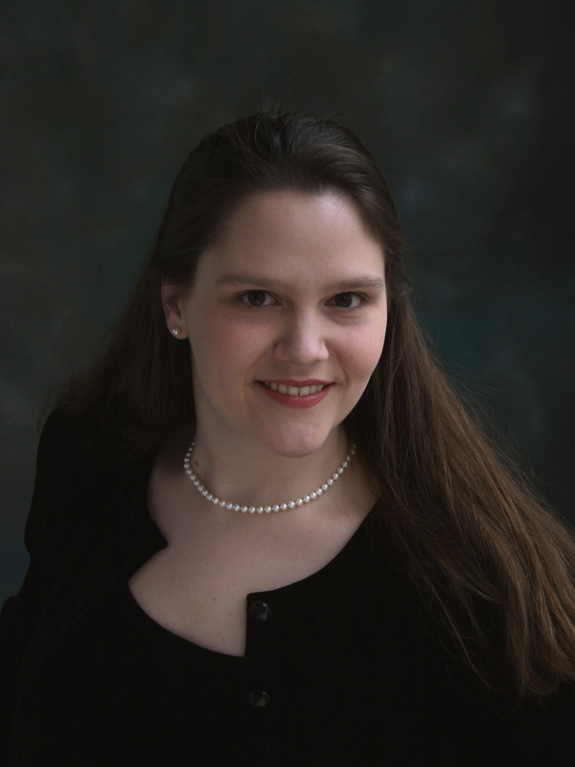
Mary Wannamaker Huff, Artistic Director, has extensive experience working with children’s choirs, beginning in 1999. She has prepared children’s choirs for performances of Vaughan Williams’ Hodie, Britten’s Saint Nicolas, Handel’s Jephtha, Bach’s St. Matthew Passion, Mendelssohn’s Paulus, Faure’s Requiem, Menotti’s Amahl and the Night Visitors, and Mahler’s Third Symphony. Her choirs have appeared on major television networks including appearances on Saturday Night Live, Good Morning America, TODAY, and CBS Sunday Morning. Recently, the NYCCC made its Carnegie Hall debut premiering Carol Barnett’s “Mortals and Angels” with bluegrass superstars, Dailey and Vincent, and their Broadway debut in “The Man Who Came to Dinner” with Nathan Lane at Roundabout Theatre.
Among Ms. Huff’s favorite press reviews was New York Magazine’s listing of one of her chorister’s performances of Bernstein’s Chichester Psalms as one of the year’s “Top Ten Classical Events in NYC” (Dec. 7, 2008). Her recordings Simple Gifts, a collection of American and British Arts Songs, and ANGEL, sacred anthems for treble voices, are available on MSR Classics, iTunes, Amazon, and Spotify. In addition to her work with the New York City Children’s Chorus, she is also the Associate Director of Music at Madison Avenue Presbyterian Church. She is involved in all aspects of the music program including conducting the Children’s Choirs, playing the organ for liturgies, accompanying and conducting the semi-professional Church Choir, Saint Andrew Chorale and Orchestra, as well as managing the Music on Madison concert series.
Ms. Huff graduated cum laude from Furman University in 1999, and continued her musical studies on a full scholarship at Yale University where she earned a Master of Music degree in 2001. She continued further post-graduate studies in music education at Westminster Choir College specializing in the training of children’s choirs. She has taught music to children of all grade levels (K4-12) in Independent, Catholic, and inner-city schools. She was Director of Children’s Choirs at the Church of St. Ignatius Loyola in New York City from 2004 to 2012 where she developed one of the finest Catholic, graded children’s choir programs in the country. Ms. Huff is married to Andrew Henderson, and they have two energetic boys that happily sing with the New York City Children’s Chorus.
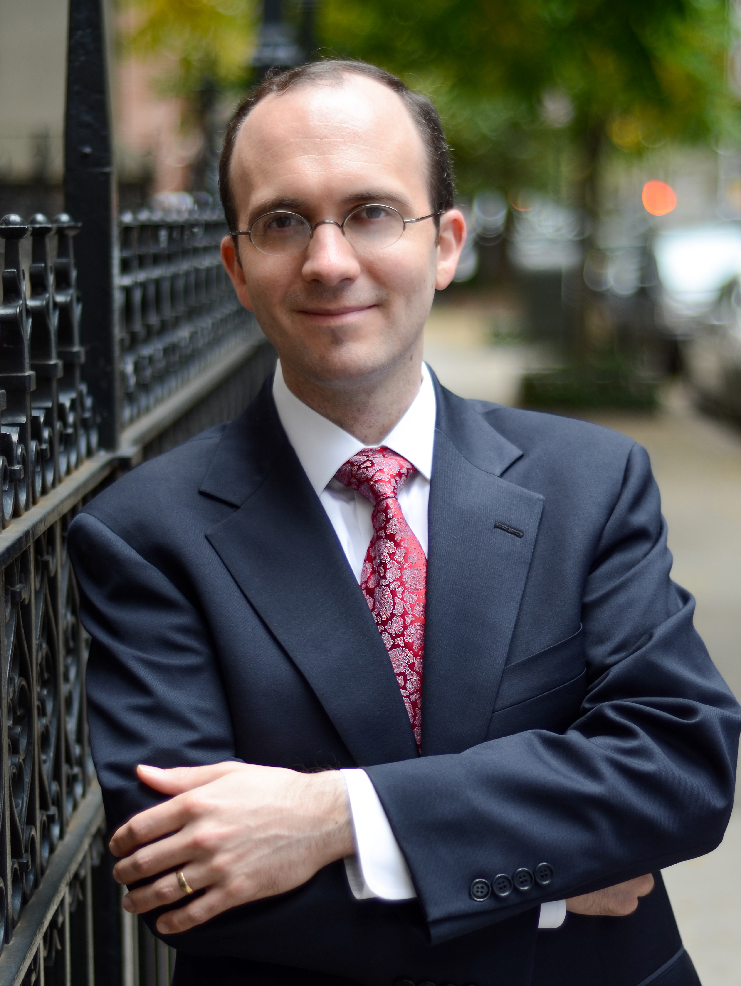
Andrew Henderson serves as Executive Director of the New York City Children’s Chorus and is the principal accompanist. Dr. Henderson has served as the Director of Music & Organist at Madison Avenue Presbyterian Church in New York City since 2005, where he oversees an extensive liturgical and choral program, including the 45-voice Saint Andrew Chorale, the New York City Children’s Chorus, in addition to the Saint Andrew Music Society’s Music on Madison concert series. He also serves as the Associate Organist at New York City’s Temple Emanu-El, as a member of the organ faculty at the Manhattan School of Music, and as the organ instructor at Teacher’s College, Columbia University. Dr. Henderson, a native of Thorold, Ontario, holds degrees in music from Cambridge and Yale Universities, and in 2007 he was awarded the Doctor of Musical Arts degree at The Juilliard School. He was a finalist in the international competition Grand Prix de Chartres in France in 2002, and won first prize in the Royal Canadian College of Organists’ biennial National Organ Playing Competition the following year. Recent performances include organ and continuo playing with the New York Philharmonic, American Symphony Orchestra, Musica Sacra, Voices of Ascension, The Oratorio Society of New York and The Collegiate Chorale, and solo recitals in Poland, Canada, and throughout the USA. His performances have been featured on the nationally-syndicated public radio programs Pipedreams and With Heart and Voice. He has been featured as a recitalist and workshop leader at national and regional gatherings of the Presbyterian Association of Musicians, the Fellowship of United Methodists in Worship and Music Arts, the Royal Canadian College of Organists, and the American Guild of Organists. A Fellow of the Royal Canadian College of Organists, his teachers have included John Tuttle, Barrie Cabena, David Sanger, Thomas Murray and John Weaver. His first solo CD, Andrew Henderson at St. John’s, Elora, was recorded and released in 2010. He can also be heard on the New York City Children’s Chorus CDs Passioni dell’aria, featuring a work for children’s chorus and piano by NYC composer Roberto Perino, and Simple Gifts, released in 2015 on the MSR Classics label.
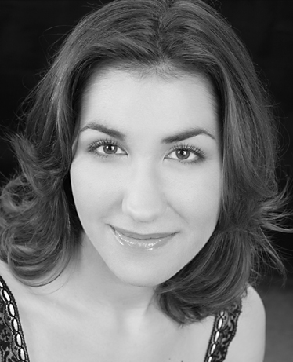
Helen Karloski, Administrative Assistant, works in all facets of the New York City Children’s Chorus. She is a Pittsburgh native and an outstanding mezzo-soprano based in New York City. A versatile artist, she is at home in a variety of musical styles including oratorio, opera, and chamber music. The New York Times wrote of her performance in Georg Philip Telemann’s rarely performed oratorio Der Tag des Gerichts, “Helen Karloski commanded attention as Reason.” Ms. Karloski made her Lincoln Center debut in Mozart’s Solemn Vespers with the Mostly Mozart Festival under the baton of Iván Fischer. Her other solo engagements include Vivaldi’s Gloria with the Pittsburgh Symphony Orchestra, Dvořák’s Stabat Mater with the Omaha Symphony, Haydn’s Theresienmesse with Voices of Ascension, Bach’s Magnificat with the Victoria Bach Festival, and Bach’s St. Matthew Passion and Brahms’ Alto Rhapsody with St. Andrew’s Music Society.
Ms. Karloski received the Ellen Lopin Blair Award for First Place in the 2015 Lyndon Woodside Oratorio Solo Competition. An accomplished ensemble singer, Ms. Karloski performs regularly with Conspirare, where she was featured on the Grammy-winning recording The Sacred Spirit of Russia, Voices of Ascension, Musica Sacra, Santa Fe Desert Choral, and Handel and Haydn Society. Favorite opera and theater performances include The Cunning Little Vixen (Hen) and My Fair Lady starting Kelsey Grammar and Kelli O’Hara with the New York Philharmonic. Ms. Karloski holds a Bachelor of Fine Arts in Vocal Performance from Carnegie Mellon University.
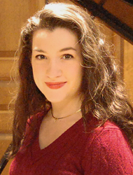
Shannon Murphy, Preparatory Division Teacher, found her love of music at a young age, starting piano lessons at age four. She started teaching in her senior year of high school, when she decided to pursue musical studies in college. In 2012 she graduated with a B.M. in Piano from Westminster Choir College of Rider University in Princeton, NJ, where she studied with Ena Bronstein-Barton. While acquiring her degree, she broadened her experience with studies in piano pedagogy, organ, voice and accompanying. She studied choral conducting with Dr. James Jordan and sang with the Westminster Symphonic Choir under the baton of conductors such as Berliner Philharmoniker director Sir Simon Rattle, and Philadelphia Orchestra director Yannick Nézet-Séguin. Currently, she is Music Director at Messiah’s Reformed Fellowship in Manhattan, NY. Since 2013 she has taught the Preparatory Division classes of the New York City Children’s Chorus. She teaches piano privately in Brooklyn and Manhattan.
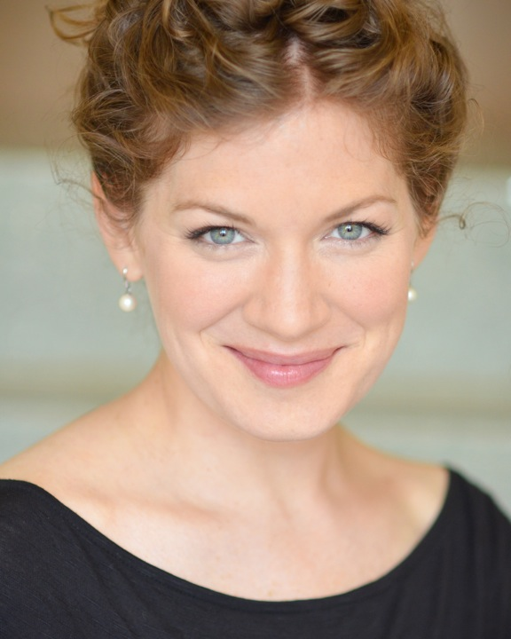
Katherine Wessinger, Private Voice Teacher, is a gifted soprano, having appeared in concert and opera in New York City and throughout the United States. Her recent performance in Haydn’s Creation garnered ample praise from the New York Times: “Ms. Wessinger’s light, clear voice was beautifully suited to Gabriel’s music…she has a genuinely angelic voice and sang with charm and grace” (Tommasini). In addition to her exceptional talent as a singer, Ms. Wessinger is also an exceptional teacher, particularly gifted with teaching young voices. Mary Huff, Artistic Director of the NYCCC, says about Ms. Wessinger: “I have had the good fortune of working with many fine vocal pedagogues in my career teaching children. None can match Katherine Wessinger, who has both a flawless technique and an equally encouraging and demanding rapport with her students. She is the finest teacher for individual vocal study I know for children.” Students who wish to pursue private vocal instruction outside of their NYCCC rehearsals should be in contact with Ms. Huff about setting up lessons with Ms. Wessinger at MAPC.

